

Design & Innovation Project (DIP)

Project Report

Smart Monitoring Electronic System for Environmental Noise and Dust

Project Group: E031

School of Electrical and Electronic Engineering

Academic Year 2024/25

Semester 1

Table of Contents

1. Purpose / Project Objectives
2. Project Summary
3. Scope
4. Schedule
5. Cost / Benefit
6. Outcome / Expected Outcomes
7. Project Management Review
8. Reflection
9. References

Appendix

Acknowledgement

We would like to express our gratitude to our main supervisor, Associate Professor Chan Pak Kwong, project lab technician, Mr Tay, for their support and assistance throughout the period of this Design and Innovation Project (DIP).

Table of Contents

Chapter 1 Purpose/ Project Objectives 4

Chapter 2 Project Summary 5

Chapter 3 Project Scope 7

3.1 Project Deliverables 7

3.1.1 Conditions 7

Chapter 4 System Design 8

4.1 Hardware 8

4.1.1 NodeMCU ESP8266 8

4.1.2 SEN0232 9

4.1.3 GY-BME280 11

4.1.4 PMS7003 14

Chapter 5 Schedule 17

Chapter 6 Cost 17

Chapter 7 Outcomes / Benefits 18

Chapter 8 Project Management Review 19

Chapter 9 Reflection 20

Chapter 10 Acknowledging/Declaring the Use of GAI 21

Chapter 11 References 23

# Purpose/ Project Objectives

This section provides an overview and the objectives of the project. This can be taken from the project charter. The project objective is usually written based on the SMART principles.

* Specific
* Measurable
* Achievable
* Relevant
* Time-bound

# Project Summary

This chapter describes the problem that was solved by the project. Did the project achieve its goals: was the problem solved completely, or were there some issues that will remain unsolved?

The main function of this smart environmental monitoring system is to remotely monitor the dust and noise levels of the environment in real time, using machine learning to analyse, predict and alert the user to potentially hazardous environment conditions.

The core of this system consists of a microcontroller, sensors for detecting particulate matter (PM), decibel (dB) levels, temperature and humidity and Internet of Things (IoT) platform for data storage, visualization and predictive analysis through MATLAB. Additionally, a commonly used messaging service is used to send alerts and information to users through their mobile devices. For the system to function remotely, a lithium-ion polymer (LiPo) battery and solar panels are integrated, acting as a power source and harvesting element to allow the system to operate without an external power supply. A custom designed Printed Circuit Board (PCB) is used to connect all the components of the system together allowing the system to be more reliable, durable and compact.

Even though the system was able to achieve the majority of the project’s objectives by effectively monitoring the environmental conditions and alerting the user appropriately, the system is unable to sustain for long period of operation. This was mainly due to the lack of experience with working on new components and system design. There was also no secured enclosure created for this system, which would be ideal for making the system protected and convenient for deploying in any environment.

battery cannot last for long hours even in ideal sunny conditions. This is mainly due to the poor selection of the solar panels used. The output power is more than the input power from the solar panels causing the battery to eventually deplete. This can also cause some sensors to not work properly after a while as some sensors require a consistent Voltage Input. When the battery depletes over time, the voltage output of the battery will decrease below the required voltage of the sensos.

Another area where improvements could be made is to create a secure enclosure for the system using 3D printing. The reason for not making a secured enclosure is due to time taken to troubleshoot... TO CONTINUE

# Project Scope

This section summarizes the final total scope of the project.

* Project Deliverables. This section gives an overall description of all the project outputs.
* Summary of the work/activities that were performed to produce those outputs.
* Changes. Were there any changes to the original scope? Highlight the changes / change requests,

## Project Deliverables

There are some conditions that justify this project to be successful. This is the main fundamentals that would meet the project's objective and completion of this DIP module

### Conditions

1. Integration of ESP8266 with Sensors and IoT platforms

Our microcontroller, ESP8266, is the glue to the system. Due to the IoT capabilities, the ESP8266 can allow IoT platforms to read and analyse data gathered from the hardware sensors that are directly connected to the ESP8266.

1. IoT

# System Design

## Hardware

The hardware side of the project consists of the microcontroller - ESP8266, Sensors - SEN0232, BME280, PMS7003 and Power Supply System – DC step up, Solar Charger controller, Solar Panels, LiPo Battery. All hardware modules used are connected to a custom PCB. A more detailed Specification of each module can be found in Appendix (X).

### NodeMCU ESP8266

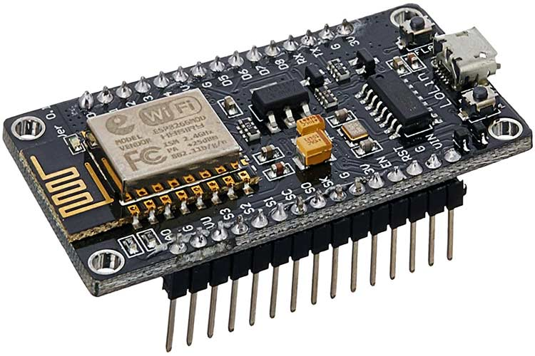[[link](https://components101.com/development-boards/nodemcu-esp8266-pinout-features-and-datasheet)]

#### Function ([link](https://www.nabto.com/is-esp8266-wifi-module-right-choice-for-you/))

This microcontroller is widely used for various IoT applications due to its surface-mountable WiFi module with an embedded ESP8266 system on chip (SoC). It is capable for onboard data processing and integration with sensors through general-purpose input/output (GPIO) pins and power supply pins. ESP8266 is programmable with the Arduino integrated development environment (IDE) that has a wide range of libraries that provides extra functionality to the microcontroller.

#### Specification

|  |  |
| --- | --- |
| Core | 1 |
| Architecture | 32 bits |
| Clock | Xtensa LX106 80-160MHz |
| WiFi | IEEE802.11 b/g/n support for WPA and WPA2 |
| RAM | 160KB - 64KB Instruction - 96KB Data |
| Flash | Extern QSPI - 512KB A 4MB |
| GPIO | 16 |
| Interfaces | SPI-I2C- Universal asynchronous receiver / transmitter (UART) - Inter-Integrated Circuit Sound (I2C) |

#### Justification

The ESP8266 is a low cost and low powered module that has built-in features that are suitable for this project like WiFi and GPIO pins. With this module being able to be programmed by Arduino IDE, it has community and documentation support resulting in a large compatibility with sensors and libraries. //to think of justification more.

### SEN0232

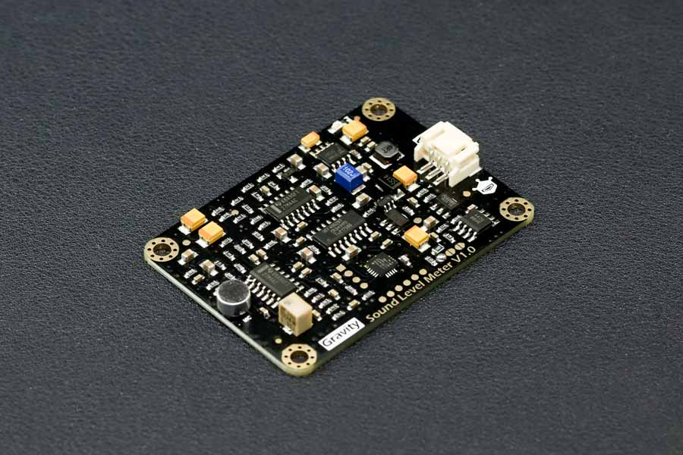

#### Function

The SEN0232 is an Analog Sound Level Meter that is designed to accurately measure the sound level of the surrounding environment. This is achieved by using an instrument circuit and a low noise microphone. With a provided connector, this is a plug-and-play component which is user friendly and compatible with a lot of IoT devices due to its wide input voltage of 3.3-5V and outputs a maximum of 2.6V which linearly follows the decibel value of the surrounding environment.

#### Specifications ([DATASHEET](https://wiki.dfrobot.com/Gravity__Analog_Sound_Level_Meter_SKU_SEN0232))

|  |  |
| --- | --- |
| Input Voltage | 3.3V - 5V |
| Current consumption | 22mA @ 3.3V, 14mA @ 5V |
| Output Voltage | 0.6V - 2.6V |
| Measuring Range | 30dBA - 130dBA |
| Measurement Error | ±1.5dB |
| Module Size | 60mm * 43mm |

#### Justification

Due to its ease of use, wide input voltage of 3.3V-5V and low input current of 22mA at 3.3V, the SEN0232 is an ideal Sound Level Meter to integrate with the ESP8266. It also has a wide measuring range of 30dBA ~ 130dBA with a measurement error of ±1.5dB. The module size is also easy to integrate with its size of 60mm*40mm.

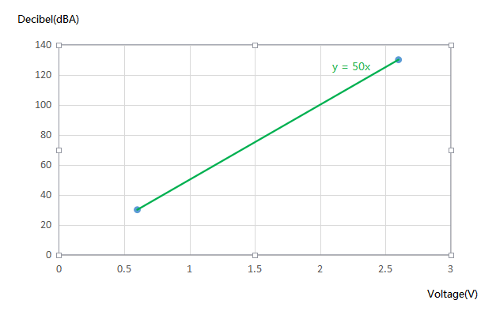[datasheet]

Additionally, since the correlation between the decibel level and is linear, this simplifies the code without the need for complex algorithms. Suitable for new and experienced students taking on this project.

### GY-BME280

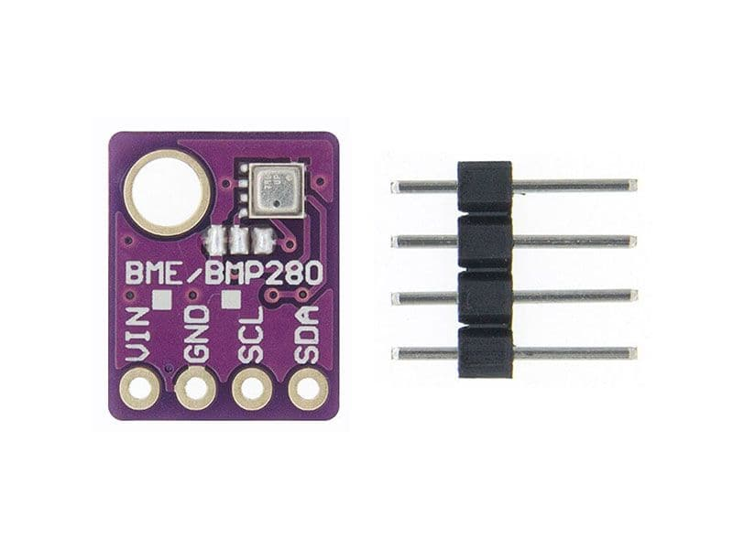[[kuriosity website](https://kuriosity.sg/products/temperatureebarometer-sensor-bmp280?variant=44757299134777&currency=SGD&utm_medium=product_sync&utm_source=google&utm_content=sag_organic&utm_campaign=sag_organic&gad_source=1&gclid=Cj0KCQiAoae5BhCNARIsADVLzZdEMZ1Vbw8gWbsL7M7gfQQkdPqbphlN-LYGAu-ZF38fQgHAUljU91MaAvcsEALw_wcB)]

#### Function

This module is an environmental sensor that measures the surrounding pressure, humidity and temperature. Thanks to its low power consumption, it can be easily implemented in battery driven systems. This sensor uses an Inter-Intergrated Circuit (I2C) or Serial Peripheral Interface (SPI) communication protocol to exchange data with a microcontroller.

#### Specification

|  |  |
| --- | --- |
| Input Voltage | 3.3V - 5V |
| Current consumption | 0.4mA |
| Temperature Range | -40°C to 85°C |
| Temperature Accuracy | ±1°C |
| Humidity Accuracy | ±3% |
| Pressure Range | 300 hPa – 1100 hPa |
| Pressure Accuracy | ±1.0 hPa |
| Module Size | 14mm*11mm |

#### Justification

This sensor can operate on a 3.3V source and communicate using I2C communication protocol that the ESP8266 is capable of. This would make the connection very simple. However, to receive readings, an Adafruit_BME280 library needs to be installed and utilized. This is an easy process to complete and the library allows the code to be readable. The module size is also easy to integrate to any system with its size of 14mm*11mm.

### PMS7003

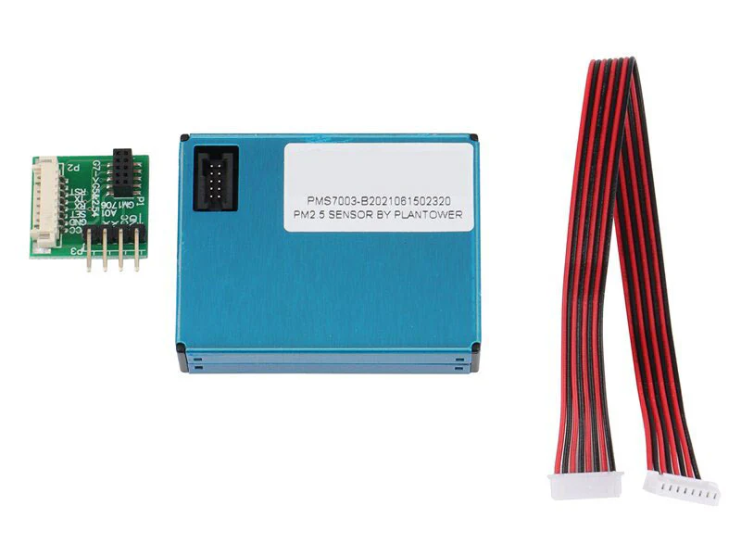[[kuriosity website](https://kuriosity.sg/products/pm2-5-dust-sensor-pms7003?_pos=1&_sid=136837bc5&_ss=r)]

#### Function

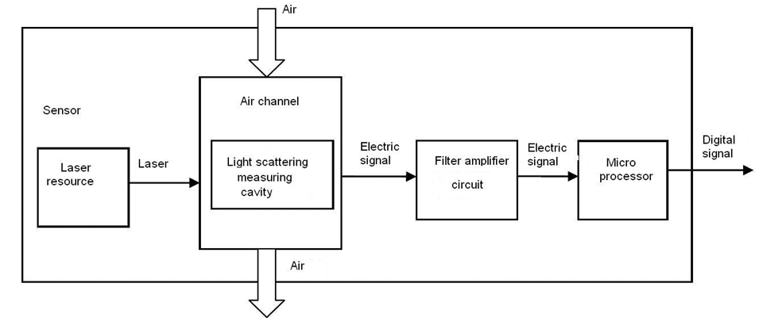(datasheet)

PMS7003 is a particle concentration sensor that obtains the number of suspended particles in the surrounding air and outputs the result digitally via I2C communication protocol. This is possible by the Laser scattering principle by using laser to radiate suspending participles which then produces scattering. With this, the microprocessor of the module is able to determine the particle diameter and number of particles based on the MIE theory calculation.

#### Specification

|  |  |
| --- | --- |
| Input Voltage | 4.5V - 5.5V |
| Current consumption (Active Mode) | ≤100mA |
| Range of measurement | 0.3μm - 1.0μm ；1.0μm - 2.5μm ；2.5μm - 10μm |
| Effective Range (PM2.5 standard) | 0μg/m³ - 500μg/m³ |
| Maximum Consistency Error (PM2.5 standard) | ±10%@100~500μ g/m³  ±10μ g/m³@0~100μ g/m³ |
| Module Size | 48mm*37mm*12mm |

#### Justification

This module is sensitive, accurate and reliable and has counting efficiency of 98% for particles larger than 0.5μm. Additional features of zero false alarms and high anti-interference capabilities allow this module to provide consistent data accuracy which makes this module suitable for varying environments. This module also has simple serial digital output that allows easy connection to the ESP8266. Lastly, its slim design allows easy integration into various devices.

# Schedule

|  |  |  |
| --- | --- | --- |
| PHASE | Planned Milestone Date | Actual Milestone Date |
| Initiating Phase |  |  |
| Planning Phase |  |  |
| Execution Phase |  |  |
| Closing Phase |  |  |
| Project End Date |  |  |

<Explain differences in between the planned and actual schedules>

<Description of Benefits>

# Cost

|  |  |  |
| --- | --- | --- |
| PHASE | Planned Costs | Actual Costs |
| Initiating Phase |  |  |
| Planning Phase |  |  |
| Execution Phase |  |  |
| Closing Phase |  |  |
| Project Total Costs |  |  |

<Explain differences between the planned and actual costs>

# Outcomes / Benefits

* Outcomes
* Benefits

# Project Management Review

This section should cover the following points

* Project initiation

Review if the initial objectives are specific, measurable, achievable, relevant, and time bound.

* Project planning

Is the project properly scheduled? Are the roles and responsibilities clearly defined?

* Project manager role

Review communication and motivation strategies and their impacts on project progress and outcome. Elaborate on monitoring and control activities necessary to ensure health progress, and how changes and challenges are managed if any.

* Cost management
* Risk management

# Reflection

This section should cover the following points

* Engineering knowledge
* Problem Analysis
* Design/development of Solutions
* Individual and Team Work
* Future Recommendations.

Within the 13 weeks, there was much engineering knowledge utilized to resolve and overcome any challenges faced. the engineering knowledge and techniques used was mainly from Circuit Analysis and Analog Electronics

# Acknowledging/Declaring the Use of GAI

Please refer to NTU's Current Policy & Guidelines on the Use of Generative AI available in NTUlearn home page and the link:

<https://entuedu.sharepoint.com/sites/Student/dept/ctlp/SitePages/Exploring-the-Impact-of-Generative-Artificial-Intelligence-(GAI)-Tools-on-Education.aspx>

* Complete the following declaration if applicable.
* Create a Paper Trail to document the input prompt, output obtained, and how you have used it

I __________________________________________________________ (student name), __________________@e.ntu.edu.sg (NTU email) honestly and sincerely make the following declaration in relation to the following course submission:

1. Name of course:

2. Course Code:

3. Instructor:

4. Title of Assignment/Project Submission:

In relation to the foregoing I hereby declare that, fully and properly in accordance with the Assignment/Project Instructions I have (check where appropriate):

i. Used GAI as permitted to assist in generating key ideas only. ☐

ii. Used GAI as permitted to assist in generating a first text only. ☐

And/or

iii. Used GAI to refine syntax and grammar for correct language submission only. ☐

Or

iv. As it is not permitted: Not used GAI assistance in any way in the development or generation of this assignment or project. ☐

I also declare that I have :

a. Fully and honestly submitted the digital paper trail required under the assignment/project instructions; and that

b. Wherever GAI assistance has been employed in the submission in word or paraphrase or inclusion of a significant idea or fact suggested by the GAI assistant, I have acknowledged this by a footnote; and that,

c. Apart from the foregoing notices, the submission is wholly my own work.

_____________________________ _________________

Student Name & Signature Date

# References

[1]

[2]

**Appendix A -** Project Members Information

|  |  |  |  |
| --- | --- | --- | --- |
|  | Name | Project contributions | Report Contribution |
| 1 | Muhammad Azfar Nasri Bin Azman | * Group Leader * Hardware Research * Hardware Connection, Testing and Troubleshooting * ESP8266 Programming * PCB Design * Telegram Bot Code * Purchasing of Hardware Items | e.g. Pages 3-6, 24-25, Chapter 2, Appendix A, B, .. |
| 2 |  | Treasurer |  |
| 3 |  | e.g. project video, final packaging, business proposal, group report editor, final project integration, final presentation presenter, secured industry sponsorship, |  |
| 4 |  |  |  |
| 5 |  |  |  |
| 6 |  |  |  |
| 7 |  |  |  |
|  |  |  |  |
|  |  |  |  |
|  |  |  |  |

Sub-Group Members List

Appendix B – (no page limit for appendices)

[1]

M. Mir, F. Nasirzadeh, H. Bereznicki, P. Enticott, S. Lee, and A. Mills, ‘Construction noise effects on human health: Evidence from physiological measures’, *Sustainable Cities and Society*, vol. 91, p. 104470, Apr. 2023, doi: [10.1016/j.scs.2023.104470](https://doi.org/10.1016/j.scs.2023.104470).